Requirements
- A start-up dashboard to show the menu and some details (studentID + name)
- Individual modules/functions for each of the 6 menu options
  - Read in the records from a user-specified filename
  - Remove all duplicate rows of data if any
  - Filter and display the data according to user-specified sorting criteria
  - Store the records displayed into a user-specified filename
- Relevant error prompting and handling wherever needed

Program Design & Implementation

Program Flow
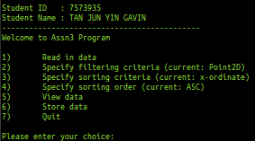

When we first run the .exe file, we will be greeted with a start up dashboard with the student ID and name followed by 7 menu options.
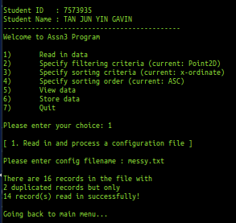
Firstly, we will read in and process the user’s input for sensor data. Within the file given by the user, we will also check for duplicate records and skip them from the read in.
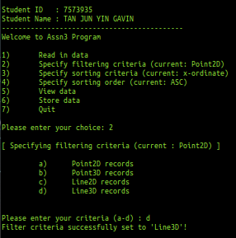
Next we will go through each of the menu options starting with “2” which is to specify the filtering criteria we want to use. There are 4 options, Point2D, Point3D, Line2D and Line3D. Following the assignment example, we will be selecting (d) or Line3D.
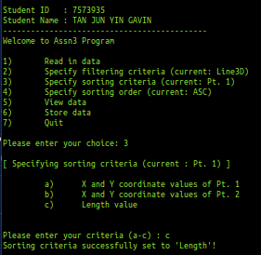
Then we will proceed to option “3” which is to specify the sorting criteria. There are 3 options, X and Y coordinates of Point 1, X and Y coordinates of Point 2 or the length value. We will be choosing (c) or Length.

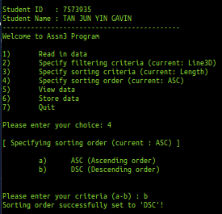
Then we will proceed to option “4” which is to specify if we want to sort the data in ascending or descending order. We will choose (b) or DSC which is also descending.

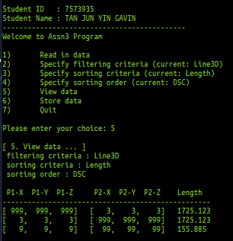
Then we will proceed to option “5”, based on the data set we have given, it will print out the data into a table as shown above

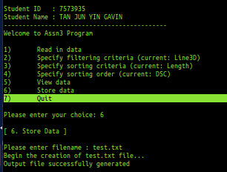
Then we will proceed to option “6”, which will prompt the user for a filename. Then, it will save the displayed data from option “5” into the path specified. As we can see here, we saved it into the file “test.txt”
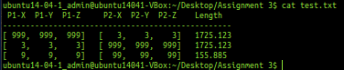

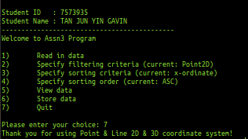
Last but not least, we will proceed to the last option, which is option “7”, which will allow the user to quit the program.

Files and Functions
The file structure was done based on the project’s requirements as shown below:
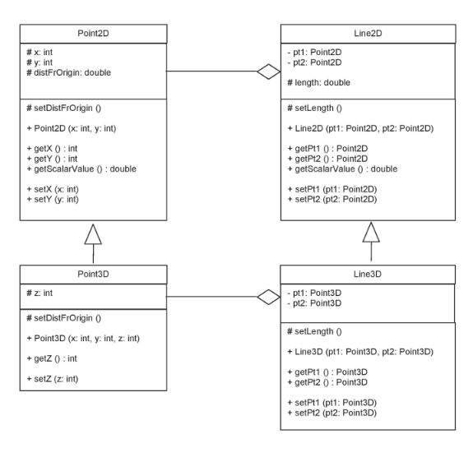

Reflections

Difficulties Faced
Creating function templates for the first time.

What Could Have Been Done Better?
I believe one area that could still be improved would be to write cleaner code, utilizing better alternatives to help reduce space and time complexity, especially when it comes to sorting and looping.

What Have You Learned?
1 key skill/knowledge which I have learned through this assignment is how to create function templates

